Lab Exercise 7- Install Minikube on Linux (Ubuntu /MacOS/Windows)

Install Minikube on Linux (Ubuntu)

sudo apt install -y docker.io # Ubuntu

sudo systemctl start docker

sudo systemctl enable docker

sudo usermod -aG docker $USER

newgrp docker

Step 2: Install kubectl

curl -LO https://storage.googleapis.com/kubernetes-release/release/$(curl -s https://storage.googleapis.com/kubernetes-release/release/stable.txt)/bin/linux/amd64/kubectl

chmod +x kubectl

sudo mv kubectl /usr/local/bin/

Verify:

kubectl version --client

Step 3: Install Minikube

curl -LO https://storage.googleapis.com/minikube/releases/latest/minikube-linux-amd64

chmod +x minikube-linux-amd64

sudo mv minikube-linux-amd64 /usr/local/bin/minikube

Verify:

minikube version

Step 4: Start Minikube

minikube start --driver=docker

Check status:

minikube status

Install Minikube on Windows

Prerequisites
- Docker Desktop installed
- Enable WSL2

Install Minikube

choco install minikube -y

OR download exe:

https://github.com/kubernetes/minikube/releases/latest

Start:

minikube start

Install Minikube on macOS

brew install minikube

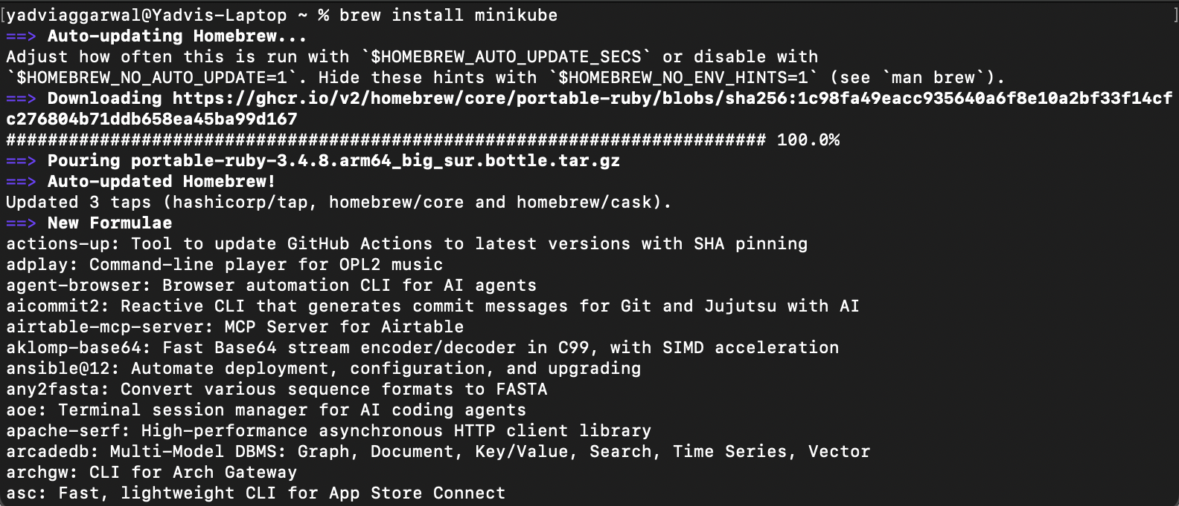

brew install kubectl

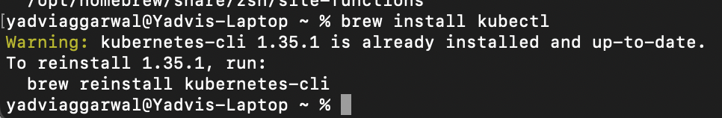

Start:

minikube start

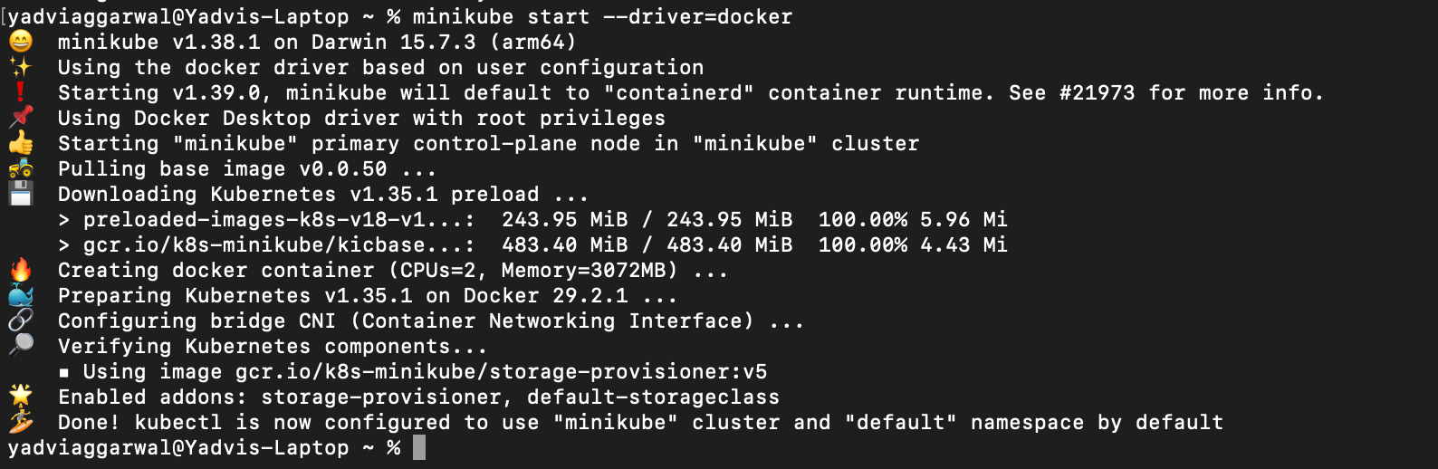

Verify Kubernetes Cluster

kubectl get nodes

Expected output:

NAME STATUS ROLES AGE VERSION

minikube Ready control-plane xx v1.xx

Useful Minikube Commands (Lab Ready)
Command | Purpose
minikube dashboard | Open K8s UI
minikube stop | Stop cluster
minikube delete | Delete cluster
minikube ssh | Access node
kubectl get pods -A | View all pods

